**SQL Query used to pull the data:**

SELECT *

FROM global_data;

SELECT *

FROM city_data

WHERE city = 'London' AND country = 'United Kingdom';

**Outline for data visualization:**

I exported the data in CSV files and centralized all data in one Excel file. Then, I used the average function to calculate a 5-year moving average for the global and city data: calculating the average for the first five years then rolling over the formula for the remainder of the periods.

After I created a line chart selecting the years, the moving average for global data and the moving average for city data as the three data sources for the chart. I then changed a bit the axis to make the data easier to read (changed the minimum and maximum bounds). Finally, I added a title to the chart and the axes and changed the legend to make it clearer.

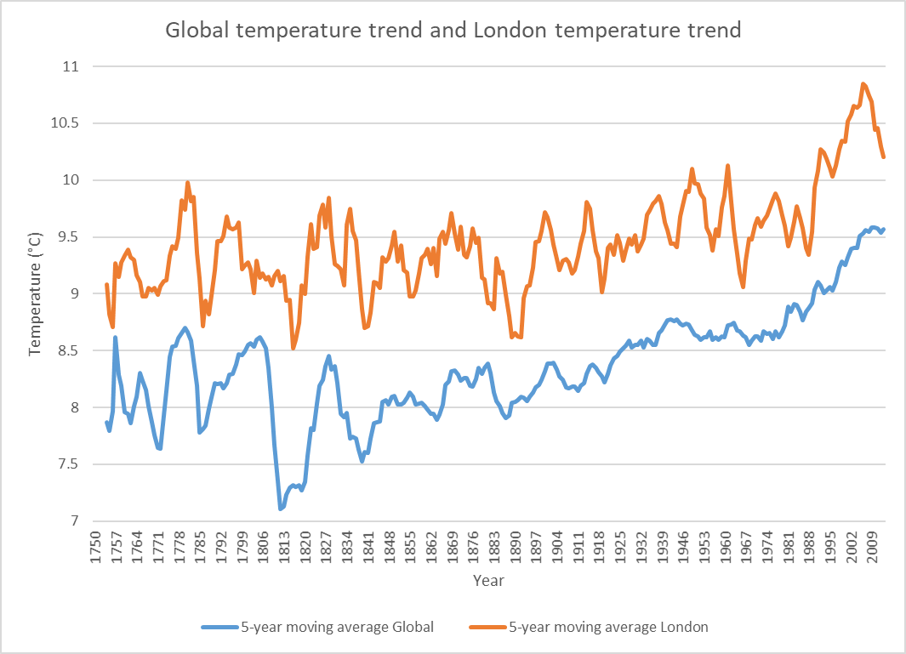

**Observations:**

* London is hotter than the global average and this has always been the case.
* Both the world and London are getting hotter over time.
* The correlation coefficient between the global temperature and the London temperature is 79%.
* Since 1880, the changes in London temperature are more important (up and down) while the global temperature keeps trending higher.